**Step 1:**

I used one laptop, because I had only one Laptop.

**Step 2:**

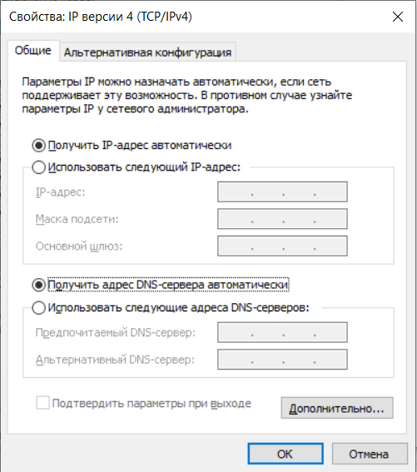

**What is the name and model number of the NIC in the “Connect using:” field?**

Realtek PCIe GbE Family Controller

**What are the first three items listed in the “This connection uses the following items:” field?**

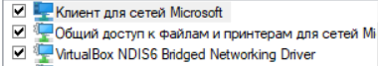

Клиент для сетей Microsoft, Общий доступ к файлам и принтерам для сетей Microsoft, VirtualBox NDIS6 Bridged Networking Driver.

**Step 3:**

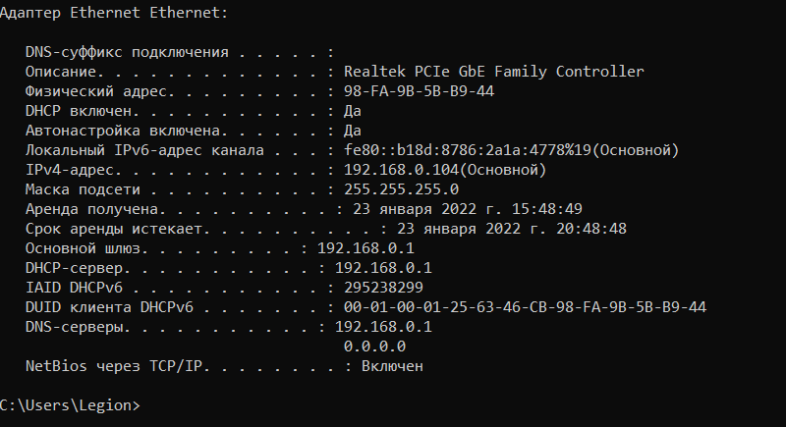

**What is the IPv4 address of the computer?**

192.168.0.104

**What is the subnet mask of the computer?**

255.255.255.0

**What is the default gateway of the computer?**

192.168.0.1

**What are the DNS servers for the computer?**

192.168.0.1 and 0.0.0.0

**What is the MAC address (physical address) of the computer?**

98-FA-9B-5B-B9-44

**Is DHCP enabled?**

Yes

**What is the IP address of the DHCP server?**

192.168.0.1

**On what date was the Lease Obtained?**

January 23, 2022 15:48:49

**On what date does the Lease Expire?**

January 23, 2022 20:48:48

**Step 4:**

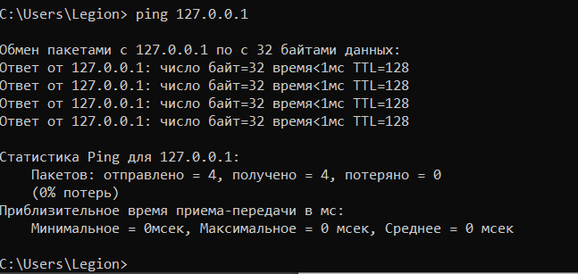

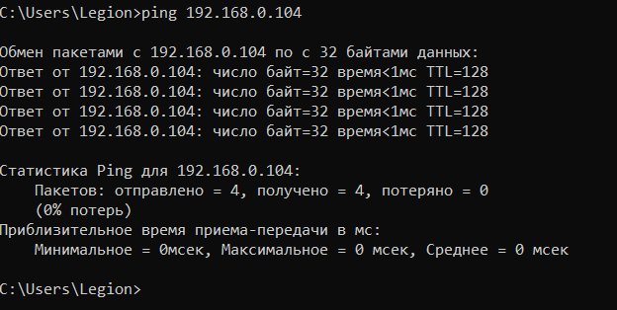

Reply from 192.168.0.104: bytes=32 time<1ms TTL=128

**Step 5:**

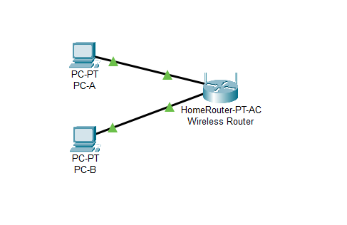

**For PC-B**

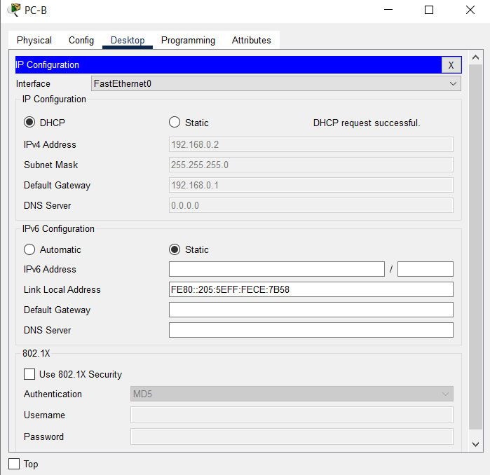

**What is the IP address of the computer?**

192.168.0.2

**What is the subnet mask of the computer?**

255.255.255.0

**What is the default gateway of the computer?**

**192.168.0.1**

**What are the DNS servers for the computer?**

0.0.0.0

**What is the IP address of the DHCP server?**

192.168.0.1

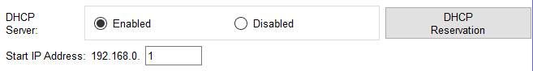

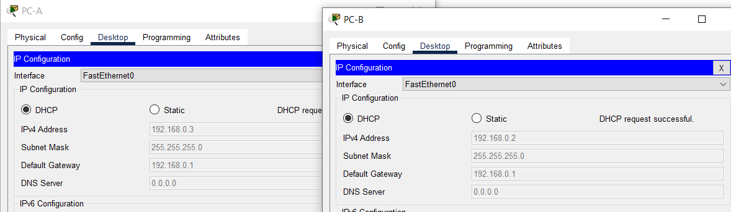

**From PC-B, ping the IP address of PC-A.**

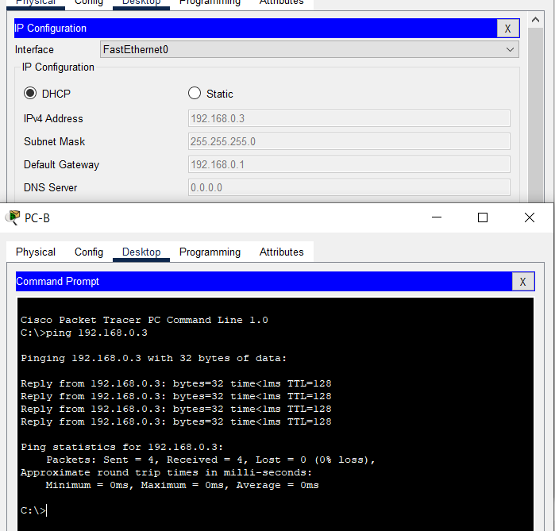

**From PC-B, ping the IP address of PC-A. Was the ping successful?** Yes

**To turn off the firewall.**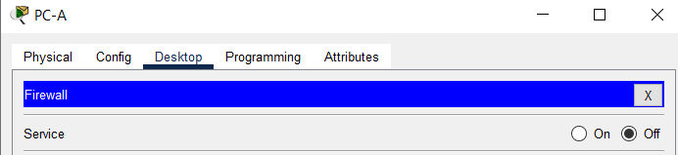

**Step 7:**

**From PC-A, ping, the IP address of PC-B**.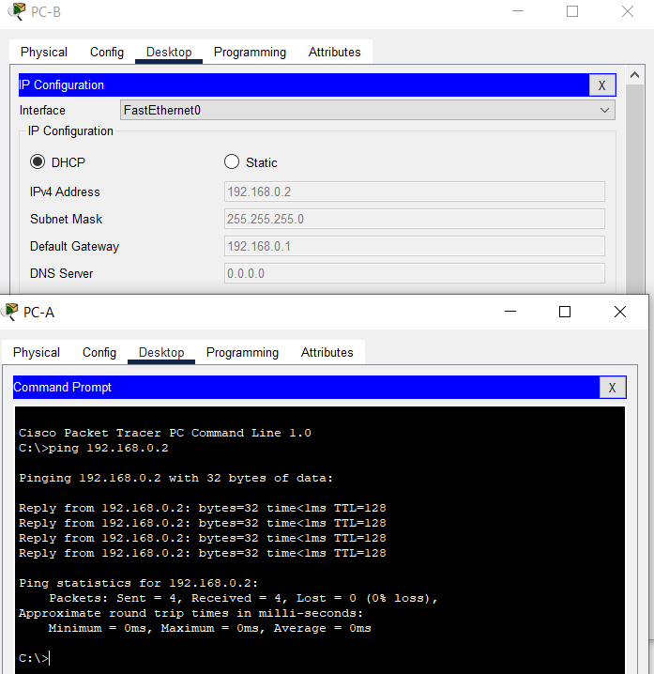

**From PC-A, ping, the IP address of PC-B. Was the ping successful?** Yes

**From PC-B, ping the IP address of PC-A. Was the ping successful?** Yes